1.4 I can appreciate (describe) the need for testing and project-based development

Software Testing

Testing is done/required in a system because mistakes are made, some of those mistakes are not important but some of them are expensive or dangerous. The need for testing is to prevent bugs, discover defects, determine reliability, reduce development costs and improve performance to the end product. The primary goal of testing is to identify all the defects and errors in the software before the implementation phase. Testing is one of the most challenging steps of the software development process. It requires close attention to detail and cannot be completed without a methodical approach, therefore, its broken down in stages.

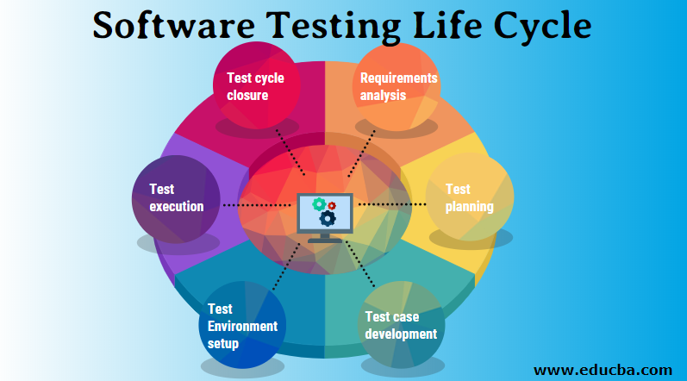

Manual testing

Manual testing is a software testing process in which test cases are executed manually without using any automated tool. All test cases are executed by the tester manually, it ensures whether the application is working the way it should, the end-user role, verifies if all the features are working properly or not.

Types of manual testing:

White box testing- White box testing involves testing the product's underlying structure, architecture, and code to validate input-output flow and enhance design, usability, and security.

Black box testing- Black box testing involves testing against a system where the code and paths are invisible.

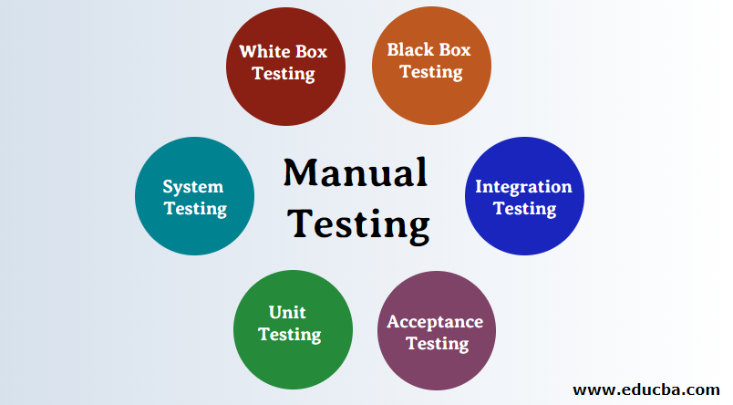

adaptabiz.com

Automation testing

Automation means the execution of a program without interaction of human beings. Automated testing is also called test automation or automated QA testing, when executed well, it relieves a lot of the manual requirements of the testing lifecycle. Automation testing, is the process of leveraging automation tools to maintain test data, execute tests, and analyse test results to improve software quality. Most tests done manually can be automated.

Types of automated testing:

**Unit testing** is when a single unit of an application is isolated from the software, to test its function, this is

performed during the development stage.

**Integration testing** is to verify how the modules communicate and behave together and to evaluate the compliance of a system.

**Smoke testing** is performed to examine whether the system build is stable or not. The main purpose is to examine if the main functionalities work properly so that testers can proceed with further testing.

**Regression testing** checks that a recent change in code doesn’t affect any existing features of the app in question. In simple terms, it verifies that changes made to the system did not break any functionality that was

Working correctly prior to their implementation.

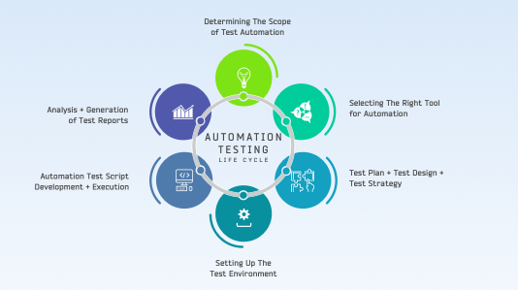

scientecheasy.com. lambdatest.com

Project based development

In project-based development, a dedicated team is assigned to tackle a single project from beginning to end. The team may consist of software developers, designers, business analysts, project managers, and software testers, in essence, people with all the skills required to bring the project to fruition. Development teams often rely on project-based development to stay on track and avoid hurdles that could disrupt the development process. Without project-based development, a software development team may begin working on a project without any clear vision or guidance, resulting in more frequent errors and confusion. Project development involves making everyone involved and aware of the purpose of the project and what steps are required to meet the end goal. Different team members can work on different parts of the project simultaneously. The Agile SRUM approach produces code is a shorter time.

powerslides.com